Name -Pushpendra Dhakar and yousuf

Roll Number -19229

Assignment-2

Carrot chasing algorithm

Summary-

Carat chasing algorithm:Carrot-chasing method that directs the motion of an unmanned device using a straightforward proportional controller.

* In this environment , we have four obstacles and one goal and one start point. We are using GPS to get the location of robots.

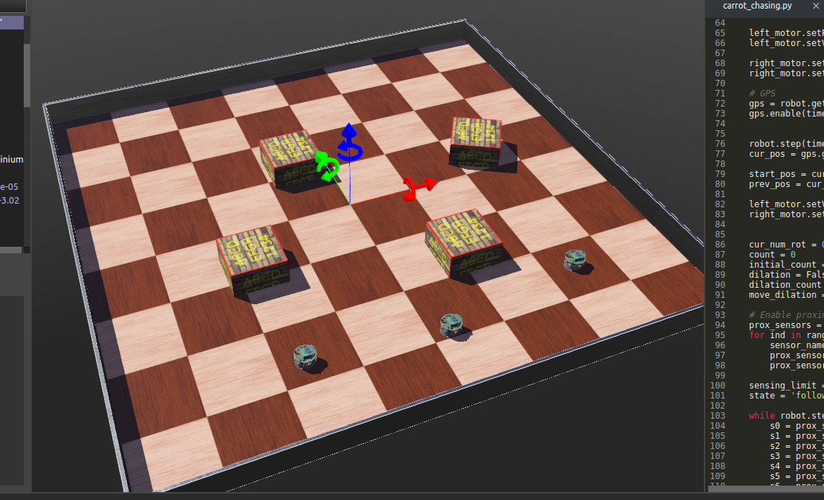

* **Implement for carrot chasing algorithm and find the shortest path**

1. First we make **carrot chasing.py** - For this .py file we make some function like angle between (robot pos and goal pos)and line between two points etc.
2. Using the concept of virtual target.
3. Using control laws.

